How to retrieve citations for a journal issue
PubMed has a feature called Single Citation Matcher to help you quickly locate an abstract if you already have all or most of the citation information.
Go to the OSF Database Page: https://www.osfhealthcare.org/libraries/databases/

Select either Citation Matcher under Clinical Tools & Images on the left or PubMed under National Library of Medicine on the right

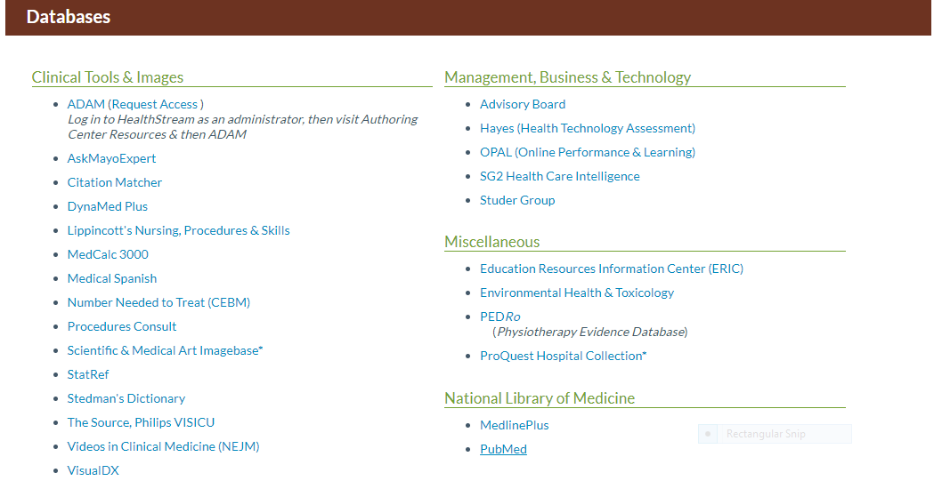

From the PubMed's homepage, select the Single Citation Matcher link under the PubMed Tools section
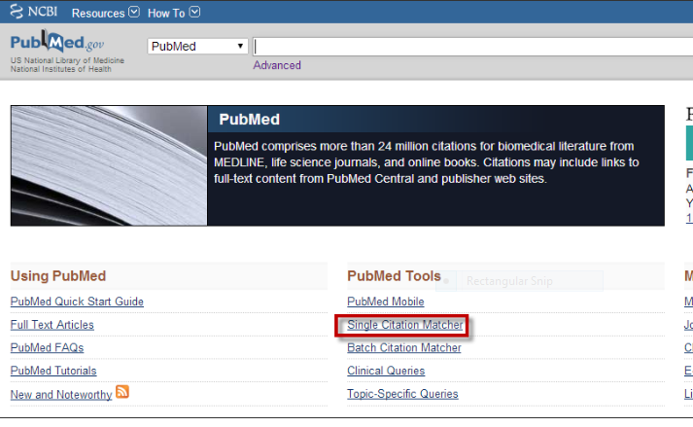
The fastest way to find a citation is to fill in the title of the article or journal title or author if you have that information available to you.

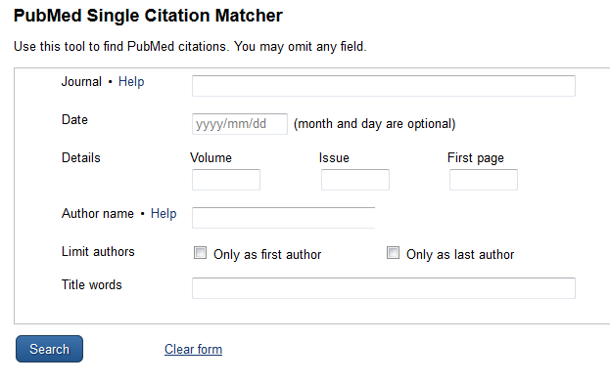
The National Library of Medicine has published a 59 second video explaining the process outlined above:
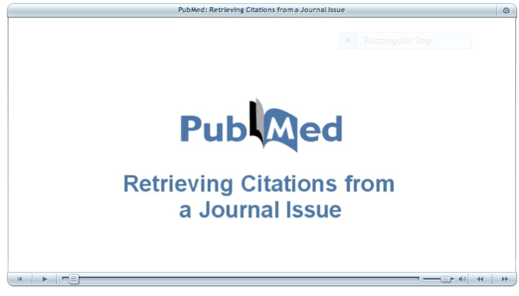
Click the link below to view https://www.youtube.com/watch?v=EgSctGOhBRk

