How to Create a Library Account to Borrow Books

Why do I need to create an account?
- To see what you have checked out from the CON Library and other I-Share libraries
- Renew items online
- Borrow books from 80+ libraries in Illinois

Instructions
- Go to the library homepage https://www.osfhealthcare.org/sfmccon/students/library/

- Go to Catalog

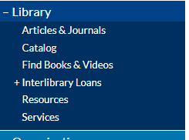
- Click on Catalog: https://vufind.carli.illinois.edu/all/vf-sfm/ and select “want to create a new account”

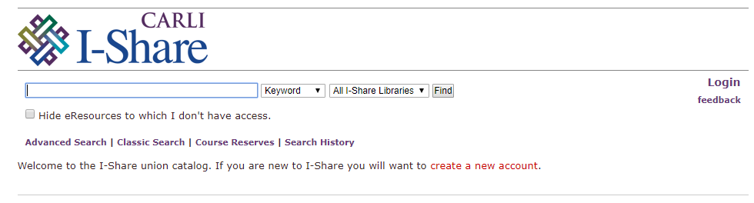
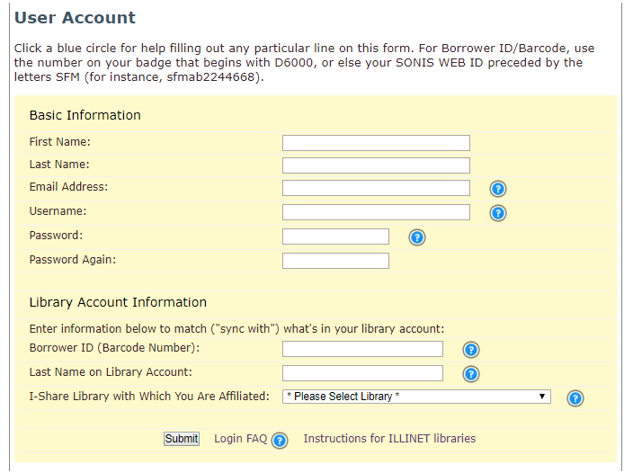

Instructions
- Fill out your name, student e-mail address, create a username/password and re-enter the password
- Enter the nine-digit barcode number beginning with the letter “D” located on the back of your student ID
- The I-Share Library that you are affiliated with is the Saint Francis College of Nursing
- Enter the library you want the book delivered to from the drop-down list and press “submit”

