Library Frequently Asked Questions

How do I obtain a Library Account? All students have a Library account. Graduate student IDs begin with “SFM” followed by their CON student number. Undergraduate students are issued bar codes beginning with D6000 at orientation that should be placed on the student’s ID. IDs become valid when the student’s first semester begins.
What is the borrowing period for undergraduates and graduate students? Textbooks can be checked out for up to two hours. Reference books may be checked out for three days. Undergraduate students may check out books from the stacks with a borrowing limit of two weeks. Graduate students may check out books from the stacks with a borrowing limit of four weeks.

May I renew books? Books may be renewed, unless there is a hold, in person, by phone (309-655-2180) or e-mail CONLibrary@osfhealthcare.org
To renew books electronically, students can access their account at:
https://vufind.carli.illinois.edu/all/vf-sfm/MyResearch/Home

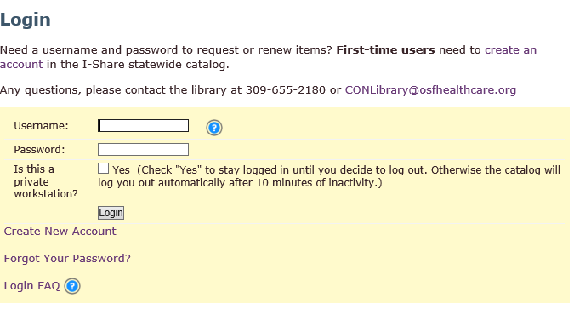

Students should choose ‘Saint Francis Medical Center College of Nursing Library” from the drop down menu and then choose the “Renew Books/My Account” tab.
How do I borrow books from other libraries? Students and faculty may borrow books and other materials through a borrowing system called I-Share if those items are not available at our library. Users will need to create an I-Share account to request and borrow I-Share items.
A list of I-Share Libraries is located at https://www.carli.illinois.edu/membership/mem-libs
Students registered at the Saint Francis Medical Center College of Nursing have the option to request collection items not owned or currently on the shelf at the College of Nursing (CON) Library from one of the I–Share Libraries through universal borrowing:
      - Students may search the contents of the Saint Francis Medical Center College of Nursing Library online catalog located at https://vufind.carli.illinois.edu/vf-sfm/
      - Students wishing to request an item from an I-Share Library may do so by selecting the “Request” tab for the item within the I-Share catalog
      - Students should indicate the I-Share Library that they wish to pick up the item.
      - Students may return the item to the I-Share Library that is most convenient for them.
      - There is no fee for borrowing from an I-Share Library.

How to create a library borrowing account?
- You can open an I-Share account by going to https://vufind.carli.illinois.edu/all/vf/
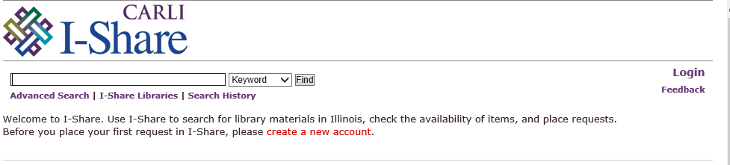
- Click “create a new account”
- When it asks for your Borrower ID enter your nine-digit student ID with SFM at the beginning, then provide your last name and the system will match you up with our library.
- To find the books in advanced search, click on the title and you’ll see a list of libraries who own it, choose “Request 1st available” and the system will choose for you.
- Our library will appear as the pick-up location, but you can also select another library if more convenient (e.g., Milner Library at ISU, Heartland Community College, ICC or Eureka College).
- When the book arrives, you will be contacted
Can I obtain articles through interlibrary loan? For items not owned by an I-Share Library, students can make requests through the library’s website at https://www.osfhealthcare.org/sfmccon/students/library/interlibrary-loans/
Can I request my textbooks through ILL? Few libraries purchase textbooks and even fewer have the most recent editions. When libraries do purchase textbooks, they usually reserve them for campus-use only and do not lend them to other libraries. So, the book may not be available for the entire semester and may be subject to recall at any time.

How will I know when the item is in and where do I pick it up? We will send you an e-mail when your item arrives. Articles are usually delivered as pdfs. Books should be picked up promptly at the circulation desk to maximize the entire loan period.
How long can I keep books borrowed from other libraries? For items borrowed from another library, the duration of the loan and any restrictions on using the item is determined by the library sending them. It is usually between three to six weeks. They also determine if a renewal for the item is allowed.
How do I access the databases? OSF Libraries uses Open Athens to access library resources such as the database. Users will need to sign in with their student account at https://register.openathens.net/osfhealthcare.org/register Please register for an account with your student e-mail address. Registering for an Open Athens account will also allow you to access the online writing platform, APA Style CENTRAL.

Where can I find journal articles?
- Use the Google Chrome browser to search databases
- Go to https://www.osfhealthcare.org/sfmccon/students/library/articles-journals/
- Click the OSF Libraries website, under “OSF Resources” select Databases under “Most Popular Resources”
- When you arrive at the OSF Database page, scroll and select either “CINAHL Plus” under EBSCO Host, “PubMed” under National Library of Medicine, or “Journals@Ovid” under Ovid.
- Type your keywords in the search box in any of the databases using the default advanced search function.
- Press “view results” and you can narrow the list by selecting the “edit” button to limit by publication date, research article or author
(e.g., author is a nurse)
- For more information, view the “How to Database Search” tutorial at https://osfiol.hosted.panopto.com/Panopto/Pages/Viewer.aspx?id=7402d9b7-caa8-44c6-90b0-a952010d261f

