How to Search Our Collection from Your Mobile Device

Download Instructions
- Download the app to your mobile device: https://minrvaproject.org/download.php

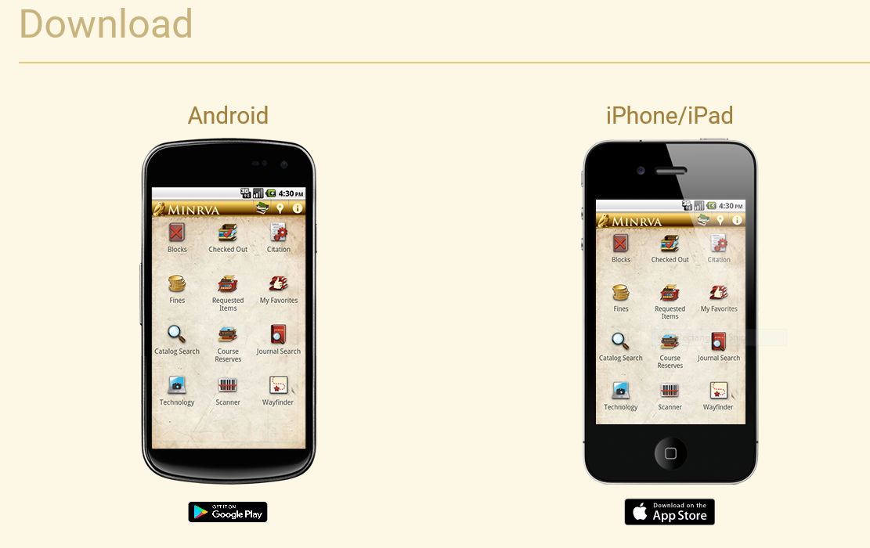
- Select the “Saint Francis Medical Center College of Nursing” location from the drop down on the upper right corner of the app screen.
- To login, you will need an I-Share account. If you do not have one, click on the link and fill out the form below: https://vufind.carli.illinois.edu/all/vf/MyResearch/Account?followup=/all/vf/MyResearch/Home

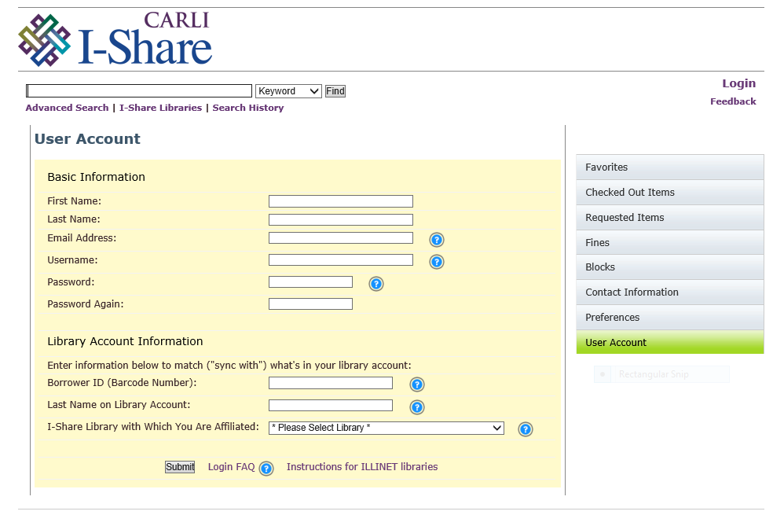

Instructions
- Fill out your name, student e-mail address, create a username/password and re-enter your password
- Enter the nine-digit barcode number beginning with the letter “D” located on the back of your student ID
- The I-Share Library that you are affiliated with is the Saint Francis College of Nursing and press “submit”

Library Catalog
- Go to the library home page: https://www.osfhealthcare.org/sfmccon/students/library/ and select “Catalog”

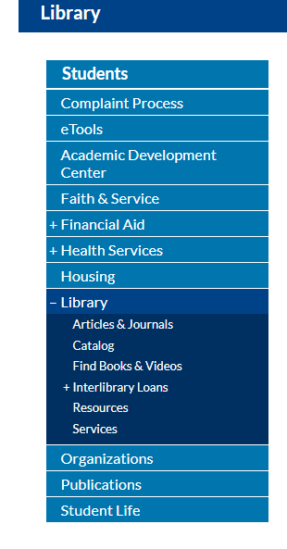
Instructions from the I-Share Catalog
- Enter either the keyword, title, subject, author or ISBN of the book in the first drop-down menu and select “Local Catalog Only” in the second drop-down menu, then press “Find”

