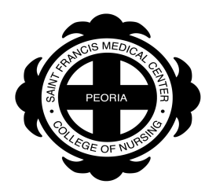
Saint Francis Medical Center College of Nursing
“A Tradition of Excellence in Nursing Education”

2019/2020 Institutional Student Account Refund Policy

A student who officially withdraws from the College or course(s) may receive a full or partial refund (credit) according to the following schedule. No refund for a college dorm room is given to a student living on campus after the 4th week of class. The withdrawal date is established by the student’s completion of all official steps for completing the process and is based on the date that the Registrar’s Office records the withdrawal. If a student withdraws from the college or any course(s) at any time without having completed the official process, no refund credit will be made. The College reserves the right to modify the refund schedule as circumstances may dictate.

Fall and Spring Semesters

- Weeks 1 & 2: 100% Refund
- Week 3: 40% Refund
- Week 4: 20% Refund
- After Week 4: 0% Refund

Summer Session

- Week 1: 100% Refund
- Week 2: 20% Refund
- After Week 2: 0% Refund

Additional Notes:

The student’s allocation of any refund is distributed only after the requirements of federal and non-federal aid programs are satisfied. See the Financial Aid Return of Funds Policy for additional information.

