READ THIS FIRST!
The College of Nursing has no bookstore. Textbooks can be purchased at the Peoria Barnes and Noble store (request them at the checkout counter), or purchased or rented online. Titles, prices, and quantity in stock are subject to change. Prices posted are provided by the publishers and represent the price they charge to the public. If substantive changes are made to this list after publication, your instructor will contact you. If you have questions, please call the College Library at 309-655-2180.

Textbooks Included in Tuition
Some of your textbooks have been purchased by the College of Nursing. If the booklist states the book was purchased institutionally, DO NOT BUY AGAIN. You may choose to rent or purchase a physical copy, but you will receive the e-book and access code on the first day of class regardless. These fees are non-refundable.
Look at the textbook list to determine which additional books you need to buy separately.

Course | Title | Author | Copyright | ISBN/Publisher | Price | Status | Included in Elsevier package
304 Nursing & Healthcare Ethics  Enrollment: 115 | Nursing Ethics: Across the Curriculum and Into Practice | Butts & Rich | 2020  5th ed | 9781284170221  Jones & Bartlett | $102.95 | Required | N/A
304 | Ethical and Religious Directives for Catholic Health Care Service | U.S. Conference of Catholic Bishops | 2018  6th ed | http://www.usccb.org/about/doctrine/ethical-and-religious-directives/upload/ethical-religious-directives-catholic-health-service-sixth-edition-2016-06.pdf  U.S. Conference of Catholic Bishops |  | Required | N/A | 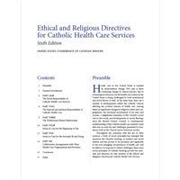
304 | Code of Ethics for Nurses with Interpretive Statements | American Nurses Association | 2015 | 9781558105997  American Nurses Association | $33.95 | Required | N/A | 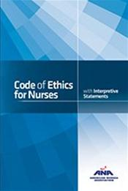
318 Research for Nursing Practice  Enrollment: 115 | Essentials of Nursing Research: Appraising Evidence for Nursing Practice | Polit & Beck | 2018  9th ed | 9781496351296  Wolters Kluwer | $99.99 | Required | N/A | 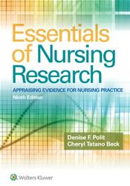
322 Concepts of Care for the Older Adult  Enrollment: 90 | Gerontologic Nursing | Meiner & Yeager | 2019  6th ed | 9780323498111  Elsevier | Institutional | Required | J2 | 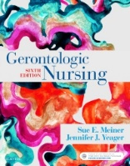

Course | Title | Author | Copyright | ISBN/Publisher | Price | Status | Included in Elsevier package
322 | Sherpath for Gerontologic Nursing (online resource) | Meiner & Yeager | 2019  6th ed | 9780323679312  Elsevier | Institutional | Required | J2
322 | Concepts for Nursing Practice | Giddens | 2017  2nd ed | 9780323374736  Elsevier | $113.00 | Required for all 4 semesters | N/A | 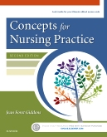
322 | Understanding Pathophysiology | Huether & McCance | 2017  6th ed | 9780323354097  Elsevier | $131.00 | Elective | No | 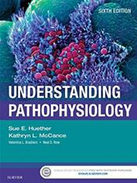
322 | Publication Manual of the American Psychological Association | APA | 2020  7th ed | 9781433832154  APA | $31.99 | Required | N/A
330 Conceptual Basis of Nursing II Theory  Enrollment: 90 | Concepts for Nursing Practice | Giddens | 2021  3rd ed | 9780323581936  Elsevier  NEW EDITION! | $119.00 | Required for all 4 semesters | N/A | 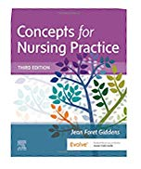
330 | Maternity & Women’s Health Care | Lowdermilk et al | 2020  12th ed. | 9780323556293  Elsevier  NEW EDITION! | Institutional | Required | J2 | 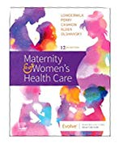

Course | Title | Author | Copyright | ISBN/Publisher | Price | Status | Included in Elsevier package
330 | Sherpath for Maternity & Women’s Health Care (online resource) | Lowdermilk et al | 2020  12th ed | 9780323721363  Elsevier | Institutional | Required | J2
330 | Varcarolis’ Foundations of Psychiatric-Mental Health Nursing | Halter | 2018  8th ed | 9780323389679  Elsevier  NEW BOOK FOR COURSE! | Institutional | Required | J2 | 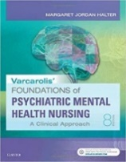
330 | Sherpath for Varcarolis’ Foundations of Psychiatric-Mental Health Nursing (online resource) | Halter | 2020  8th ed | 9780323710220  Elsevier | Institutional | Required | J2
330 | Psychiatric Nursing: Assessment, Care Plans, and Medications | Townsend | 2018  10th ed | 9780803660557  F A Davis | $49.95 | Required | N/A | 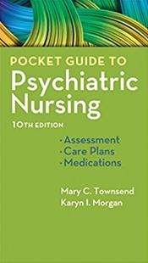
412 Trends & Issues for Professional Nursing  Enrollment: 75 | Nursing Today: Transition and Trends | Zerwekh | 2021  10th ed | 9780323642088  Elsevier  NEW EDITION! | $84.95 | Required | N/A | 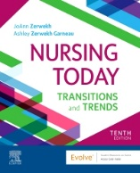

Course |  | Title | Author | Copyright | ISBN/Publisher |  | Price | Status | Included in Elsevier package
412 | Nursing Today: Transition and Trends (online resource) |  | Zerwekh | 2021  10th ed | 9780323763509  Elsevier |  | Institutional | Required |  | N/A
426 Conceptual Basis of Nursing III Theory  Enrollment: 90 |  | Concepts for Nursing Practice | Giddens | 2021  3rd ed | 9780323581936  Elsevier  NEW EDITION! | $119.00 |  | Required for all 4 semesters | N/A
426 |  | Lewis’s Medical-Surgical Nursing: Assessment & Management of Clinical Problems | Harding et al. | 2020  11th ed | 9780323551496  Elsevier  NEW EDITION! | Institutional |  | Required | S1 |  | 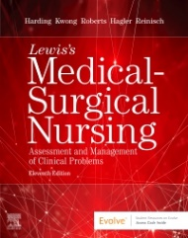
426 |  | Sherpath for Medical-Surgical Nursing (online resource) | Harding et al. | 2020  11th ed | 9780323756846  Elsevier |  | Institutional | Required | S1
426 |  | Wong’s Nursing Care of Infants & Children  Textbook only | Hockenberry, Wilson & Rodgers | 2019  11th ed | 9780323549394  Elsevier |  | Institutional | Required | S1
426 |  | Sherpath for Wong’s Nursing Care of Infants & Children (online resource, includes textbook) | Hockenberry et al | 2019  11th ed | 9780323679176  Elsevier |  | Institutional | Required | S1

Course |  | Title | Author | Copyright | ISBN/Publisher | Price | Status | Included in Elsevier package
431.2 Emergency Nursing Care of Clients  Enrollment: 15 |  | Sheehy’s Emergency Nursing: Principles & Practice | Emergency Nurses Association | 2020  7th ed | 9780323485463  Elsevier  NEW EDITION! | $119.00 | Required | N/A | 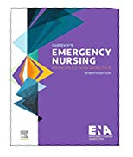
431.2 |  | Priorities in Critical Care Nursing | Urden, Stacy, & Lough | 2020  8th ed | 9780323531993  Elsevier  NEW EDITION! | $108.00 | Required | N/A | 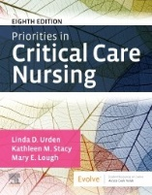
431.2 |  | Lewis’s Medical-Surgical Nursing: Assessment & Management of Clinical Problems | Harding et al. | 2020  11th ed | 9780323551496  Elsevier  NEW EDITION! | $170.00 | Required | N/A
431.3 Substance Abuse & Addictive Behavior in Society  Enrollment: 15 |  | Drugs, Society, and Human Behavior | Hart & Ksir | 2018  17th ed | 9781259913860 bound print copy  9781260240955 loose leaf  9781260240924 digital  McGraw-Hill Education | $227.33  $160.00  $75.00 rental for 6 months | Required | N/A
431.4 Nursing Care of the Critically Ill Adult  Enrollment: 10 |  | Lewis’s Medical-Surgical Nursing: Assessment & Management of Clinical Problems | Harding et al. | 2020  11th ed | 9780323551496  Elsevier  NEW EDITION! | $170.00 | Required | N/A
Course | Title |  | Author | Copyright | ISBN/Publisher | Price | Status | Included in Elsevier package
431.4 |  | Priorities in Critical Care Nursing | Urden, Stacy, & Lough | 2020  8th ed | 9780323531993  Elsevier  NEW EDITION! | $108.00 | Required | N/A
431.15 Transcultural Nursing |  | Transcultural Nursing: Assessment & Intervention | Giger | 2021  8th ed | 9780323695541  Elsevier  NEW EDITION! | $81.95 | Required | N/A | 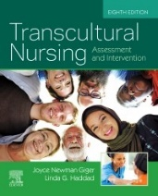
434 Concepts in Nursing Management  Enrollment: 115 |  | Leadership Roles and Management Functions in Nursing: Theory and Application | Marquis & Huston | 2021  10th ed | 9781975139216  Wolters Kluwer  NEW EDITION! | $89.99 | Required | N/A
438 Conceptual Basis of Nursing IV Theory  Enrollment: 80 | Concepts for Nursing Practice |  | Giddens | 2021  3rd ed | 9780323581936  Elsevier  NEW EDITION! | $119.00 | Required for all 4 semesters | N/A
438 |  | Community & Public Health Nursing: Evidence for Practice | DeMarco & Healey-Walsh | 2019  3rd ed | 9781975111694  Wolters Kluwer  NEW EDITION! | $115.99 | Required | N/A | 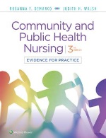

Course |  | Title | Author |  | Copyright | ISBN/Publisher | Price | Status | Included in Elsevier package
438 |  | Lewis’s Medical-Surgical Nursing: Assessment & Management of Clinical Problems | Harding et al. |  | 2020  11th ed | 9780323551496  Elsevier  NEW EDITION! | $170.00 | Required | N/A
438 | Sherpath for Medical-Surgical Nursing (online resource) |  | Harding et al. | 2020  11th ed |  | 9780323756846  Elsevier | Institutional | Required | S1
438 |  | Priorities in Critical Care Nursing | Urden, Stacy, & Lough |  | 2020  8th ed | 9780323531993  Elsevier  NEW EDITION! | $108.00 | Required | N/A
439 Conceptual Basis of Nursing IV Clinical  Enrollment: 80 |  | Saunders Comprehensive Review for NCLEX-RN Examination | Silvestri |  | 2019  8th ed | 9780323358415  Elsevier  NEW EDITION! | $68.95 | Required | S2 | 