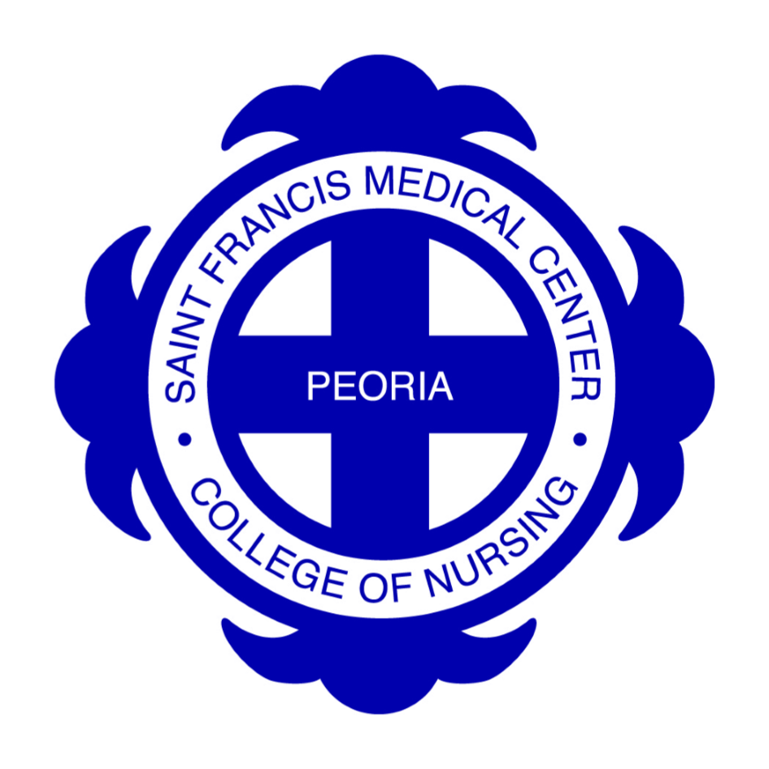

Saint Francis Medical Center College of Nursing

Peoria, Illinois

Master of Science in Nursing
and
Post Graduate Certificate

Application for Admission

2-19-2021

Saint Francis Medical Center College of Nursing
511 N.E. Greenleaf Street, Peoria, Illinois 61603

Master of Science in Nursing
Post Graduate Certificate
Saint Francis Medical Center College of Nursing is accredited by the Higher Learning Commission and the MSN Program holds program accreditation from the Commission on Collegiate Nursing Education (CCNE), 655 K Street, NW, Suite 750, Washington, DC, 20001, Ph: 202.887.6791.

Admission Requirements

- Please send the following to the Admissions Office:
1. Complete Application for Admission
Priority Date - Priority acceptance is given to completed application materials received by April 1st for fall semester and Oct 1st for spring semester, although applications are accepted year-round.
2. Pay nonrefundable $50.00 application fee.
3. Request that the registration office of all higher education institutions previously attended send an official transcript directly to our Admissions Office. Please note that we must receive an official transcript from every institution, even if transfer credit from that institution appears on the transcript of another institution.
4. Bachelor of Science in Nursing from a program which is ACEN, CCNE, or CNEA accredited and regionally accredited.
5. Grade point average (GPA) of 2.8 on a 4.0 scale for MSN and 3.0 on a 4.0 scale for post graduate certificate.
6. Evidence of current, unencumbered licensure to practice as a Registered Nurse in state where practicing.
7. Evidence of completion of undergraduate health assessment and nursing research with a minimum grade of “C” for both courses.
8. A 500-750 word typed essay detailing professional and educational goals.
9. Evidence of one year of professional nursing experience preferred.
10. Three letters of recommendation from persons who can speak to the applicant’s ability
to undertake Graduate study. One letter from a nursing faculty from the student’s baccalaureate education
is preferred. The references providing the recommendations are to mail their letters directly to
the Admissions Office/Graduate Programs. (SFMC CON, 511 NE Greenleaf St., Peoria, IL 61603).
11. The College may request an interview.
12. Post Graduate Certificate applicants must hold an MSN degree from a program which is ACEN, CCNE, or CNEA accredited and regionally accredited.
13. Additional requirements for Neonatal Nurse Practitioner and Psychiatric Mental Health Nurse Practitioner options:
NNP-Must have at least two years of fulltime experience (or the equivalent) as an RN in a Level
III or IV NICU within the past five years before starting clinical courses, but may start theory
courses without the required clinical experience. Also, must hold and maintain a current Neonatal
Resuscitation Program Certificate.
Psychiatric Mental Health Nurse Practitioner-students must have 1 year of experience (or
the equivalent) in psych-mental health within the last 5 years prior to starting the psych/mental
health-specific theory or practicum courses. Requirement is not applicable for post-graduate
certificate applicants.

- When all the above documentation has been received and evaluated, you will receive a letter from the College of Nursing confirming your admission status.
- Checklist
__Application
__$50.00 application fee
__Transcripts
__Three letters of recommendation to be sent directly to the College
__Copy of RN license
__Admission essay
__NNP-copy of Neonatal Resuscitation Program certification

Distance Education Student Eligibility by State:
All applicants are welcome to apply. However, due to restrictions on distance education and/or APN licensure requirements imposed by individual states, the College cannot accept students that are residents of the following states (2-19-21):

Alabama | Alaska | Arkansas- curriculum may not prepare you for licensure in AK | Arizona | California-curriculum may not prepare you for licensure in CA
Colorado | District of Columbia | Georgia | Idaho | Kansas- curriculum may not prepare you for licensure in KS
Louisiana | Minnesota | Missouri | Nebraska | New Mexico
North Dakota | New York | Oklahoma | Oregon | Pennsylvania
Rhode Island | South Dakota | Tennessee | Utah | Washington
Wyoming

The College has met state specific distance education requirements and has been given permission by the Board of Higher Education to provide this MSN/Post Graduate Certificate education to students in all states except the ones in the table above. Regulations require the College to notify students if the program does not meet the specific APN licensure requirements in your state of residence (See table above). Students should contact the State Board of Nursing for further information.

Your state not listed or other questions? If you are a potential out of state applicant and have questions about the College’s authorization eligibility to offer distance education in your home state, please contact the Graduate Dean at (309) 655-2230.

State | State Board of Nursing Web Address
Alabama | www.abn.alabama.gov
Alaska | https://www.commerce.alaska.gov/web/cbpl/professionallicensing/boardofnursing.aspx
Arizona | https://www.azbn.gov/
Arkansas | http://www.arsbn.arkansas.gov/
California | www.rn.ca.gov/
Colorado | https://www.colorado.gov/pacific/dora/Nursing
Connecticut | http://www.ct.gov/dph/site/default.asp
Delaware | https://dpr.delaware.gov/boards/nursing/
Florida | http://floridasnursing.gov/
Georgia | https://www.ncsbn.org/Georgia.htm
Hawaii | https://cca.hawaii.gov/pvl/boards/nursing/
Idaho | http://ibn.idaho.gov/IBNPortal/
Illinois | http://nursing.illinois.gov/ - Meets APN licensure requirements.
Indiana | http://www.in.gov/pla/nursing.htm
Iowa | https://nursing.iowa.gov/
Kansas | http://www.ksbn.org/
Kentucky | https://kbn.ky.gov/Pages/default.aspx
Louisiana | http://www.lsbn.state.la.us/
Maine | http://www.maine.gov/boardofnursing
Maryland | http://mbon.maryland.gov
Massachusetts | https://www.mass.gov/orgs/board-of-registration-in-nursing
Michigan | http://www.msbn.ms.gov/Pages/Home.aspx
Minnesota | http://mn.gov/boards/nursing/ - Adult Gerontology Clinical Nurse Specialist students only
Mississippi | https://www.msbn.ms.gov/
Missouri | http://www.pr.mo.gov/nursing.asp
Montana | https://www.ncsbn.org/Montana.htm
Nebraska | http://dhhs.ne.gov/publichealth/Pages/crl_nursing_nursingindex.aspx
Nevada | http://nevadanursingboard.org/
New Hampshire | http://www.nh.gov/nursing/
New Jersey | https://www.ncsbn.org/New%20Jersey.htm
New Mexico | https://nmbon.sks.com/
New York | http://www.op.nysed.gov/prof/nurse/
North Carolina | https://www.ncbon.com/
North Dakota | https://www.ndbon.org/
Ohio | http://www.nursing.ohio.gov/
Oklahoma | https://www.ok.gov/nursing - Family Nurse Practitioner (FNP) students only
Oregon | https://www.oregon.gov/osbn/Pages/index.aspx
Pennsylvania | http://www.dos.pa.gov/ProfessionalLicensing/BoardsCommissions/Nursing/Pages/default.aspx#.Vh-s6k8U_cs
Rhode Island | http://www.health.ri.gov/for/nurses
South Carolina | http://www.llr.state.sc.us/pol/nursing
South Dakota | https://doh.sd.gov/boards/Nursing/
Tennessee | https://www.tn.gov/health/health-program-areas/health-professional-boards/nursing-board.html
Texas | https://www.bon.texas.gov/
Utah | https://dopl.utah.gov/nurse/index.html
Vermont | https://www.sec.state.vt.us/professional-regulation.aspx
Virginia | https://www.dhp.virginia.gov/nursing
Washington | http://www.doh.wa.gov/
West Virginia | http://www.wvrnboard.wv.gov/Pages/default.aspx
Wisconsin | https://dsps.wi.gov/Pages/RulesStatutes/Nursing.aspx
Wyoming | https://nursing-online.state.wy.us/

Saint Francis Medical Center College of Nursing
511 N.E. Greenleaf Street
Peoria, Illinois 61603
(309) 655-3274

Application for Admission to the Masters in Nursing Program (MSN)

and Post Graduate Certificate

A non-refundable application fee of $50.00 should be returned with this application. You are urged to give careful consideration to each question on the form. It is to your advantage to fill it out completely and return it promptly to the Admissions Office of the College of Nursing. Priority acceptance is given to completed application materials received by April 1st for fall semester and Oct. 1st for spring semester, although applications are accepted year round.

Please print or type.

Date: ____________________________, 20_______ Social Security No: _________________________________

Name_______________________________________________________________________________________
(Last Name) (First Name) (Middle Initial) (Previous/Maiden Name)

Home Address: _______________________________________________________________________________
(Number and Street)
____________________________________________________________________________________________
(City) (State) (Zip) (County) (Country)

Date of Birth: ________________________________ First letter of your mother’s maiden name: ___________

Home Phone: _____________________________________ Cell Phone: ________________________________

Work Phone: _________________________ Email: __________________________________________________

U.S. Citizen: Yes No If no, please mark your status: Resident Alien or Non-Resident Alien

Non-Citizen | Please list Visa Type, Number _________________________________________________  Country of Origin____________________________________________________________

Person to be notified in emergency: _____________________________________________________________
(Name/Relationship) (Phone/Cell)

Response to the following is voluntary. The information is requested so that this institution may demonstrate its compliance with Federal regulations. Please check appropriate ethnicity option.

- Designate ethnicity Hispanic or Latino Not Hispanic or Latino

- Indicate one or more races that apply:

American Indian or Alaska Native Race and Ethnicity Unknown
Asian Two or More Races
Black or African American Unknown
Native Hawaiian or other Pacific Islander White
Non-Resident Alien

Gender: Male Female

RN Licensure: _______________________________________________________________________________
(State) (License #) (Renewal Date)

How many years of experience do you have in the nursing profession? ___________________

Have you previously applied for admission to this college? Yes No If yes, date: _____________________

Will you be requesting financial assistance: Yes No

When do you desire to enter this college? ______________________________________________________

Select the Major/Option you would like:

___Family Nurse Practitioner
___Adult-Gerontology Acute Care Nurse Practitioner
___Neonatal Nurse Practitioner
___Psychiatric Mental Health Nurse Practitioner
___Nurse Educator
___Nursing Management Leadership

___Post Graduate Certificate applicants (also indicate a major above)

Previous Undergraduate and Graduate Studies (Please list all institutions attended. Failure to list all institutions is a violation of academic integrity and may lead to dismissal from the College.)
Date  From To |  | Name of School | City and State | Major | Credential Earned  (Diploma, Certificate  Degree, No. of Credits)

Employment: List your last two work experiences, beginning with the most recent.
Dates  From To |  | Title of Position | Employer | City and State

OTHER INFORMATION: How did you find out about Saint Francis Medical Center College of Nursing?

- College or Career Fair (name of fair):________________________________________________
- Advertisement (publication name): _________________________________________________
- Alumni of the College of Nursing
- Current College of Nursing Student
- Health Care Professional (name): __________________________________________________
- Other (please explain):___________________________________________________________

I certify that all the information given in this application is complete and accurate to the best of my knowledge. I understand that inaccurate information on any part of the application may result in cancellation of admission and/or registration.

Signature ______________________________________________________ Date _______________________
2-19-2021

32018

Saint Francis Medical Center College of Nursing
511 N.E. Greenleaf Street
Peoria, Illinois 61603

Essay Guidelines for Admission

This essay is an essential aspect of the admission process and will be carefully evaluated by the Graduate Program Committee to make a decision on your direct entry into the MSN/Post Graduate Certificate program. Follow the guidelines carefully, and speak to each item listed below. The paper should be 500-750 words typed. Please do not include your name on the essay. Evaluation of the essay will include assessment of:

- Content
- Clarity of presentation
- Grammar, punctuation, etc.

Please address the following:

- Discuss your current practice area and professional role.
- Describe formal or informal leadership roles, in which you participated.
- Give specific examples of ways you have collaborated with others in a professional setting.
- Professionally, where do you see yourself in one year after you compete your degree?

Please note that this essay is graded and will be a part of determining your admission to the Saint Francis Medical Center College of Nursing Program.

2-19-2921

