The College of Nursing has no bookstore. Textbooks can be purchased at the Peoria Barnes and Noble store (request them at the checkout counter), or purchased or rented online. Titles, prices, and quantity in stock are subject to change. If substantive changes are made to this list after publication, your instructor will contact you. If you have questions, please call the College Library at 309-655-2180.
Prices posted are provided by the publishers and represent the price they charge to the public.
Jones & Bartlett have a 3-book bundle, which includes the main textbooks for the fall courses 509, 519, and 531, as well as the main book for the spring course 529. You are not required to purchase this bundle, but it is highly recommended.
Course | Title | Author | Copyright | ISBN/Publisher | Price | Status
509/519/529 | 3P's for Graduate Nursing Bundle | Rhoads/Demler/Dlugasch | 2021  1st ed | 9781284241310  Jones & Bartlett | $249.95 |  | 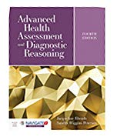
Required for all graduate courses | Publication Manual of the American Psychological Association | APA | 2019  7th ed | 9781433832154  APA  NEW EDITION! | $31.99 | Required for all graduate courses
Required for all graduate courses | Ethical and Religious Directives for Catholic Health Care Service | U.S. Conference of Catholic Bishops | 2018  6th ed | http://www.usccb.org/about/doctrine/ethical-and-religious-directives/upload/ethical-religious-directives-catholic-health-service-sixth-edition-2016-06.pdf  U.S. Conference of Catholic Bishops |  | Required for all graduate courses

Course | Title | Author | Copyright | ISBN/Publisher | Price | Status
450 Transition to Advanced Nursing Practice  Enrollment: 10 | Leddy & Pepper’s Professional Nursing | Hood | 2018  9th ed | 9781496351364  Wolters Kluwer | $84.99 | Required
500 Theoretical Foundations of Advanced Nursing Practice  Enrollment: 50 | Theoretical Basis for Nursing | McEwen & Wills | 2019  5th ed | 9781496351203  Wolters Kluwer | $76.99 | Required | 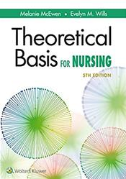
500 | Ethical and Religious Directives for Catholic Health Care Service | U.S. Conference of Catholic Bishops | 2018  6th ed | http://www.usccb.org/about/doctrine/ethical-and-religious-directives/upload/ethical-religious-directives-catholic-health-service-sixth-edition-2016-06.pdf  U.S. Conference of Catholic Bishops | $4.95 | Required
509 Advanced Health Assessment & Diagnostic Reasoning  Enrollment: 50 | Advanced Health Assessment & Diagnostic Reasoning | Rhoads & Petersen | 2021  4th ed | 9781284170313  Jones & Bartlett | $112.95 | Required  Included in bundle
509 | Advanced Assessment: Interpreting Findings & Formulating Differential Diagnoses | Goolsby & Grubbs | 2019  4th ed | 9780803668942  F. A. Davis | $89.95 | Elective | 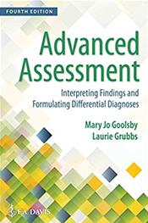

Course | Title | Author | Copyright | ISBN/Publisher | Price | Status
509 | Pediatric Primary Care: Practice Guidelines for Nurses | Richardson | 2020  4th ed | 9781284149425  Jones & Bartlett | $83.95 | Elective  for FNP students
509 | A Manual of Laboratory and Diagnostic Tests | Fischbach & Fischbach | 2018  10th ed | 9781496377128  Wolters Kluwer | $66.99 | Elective
509 | Professional 2.5V Otoscope & Ophthalmoscope Instrument Set with Leather Case |  |  |  | $98.98 | Required | Contact faculty for additional information
509 | Shadow Health Digital Clinical Experience™ | Digital Clinical Experience [Computer software]. Gainesville, FL: Shadow Health. |  | Shadow Health | $102.99 | Required | See additional information below
Also required for 509
For registration and purchase, follow the guide at https://support.shadowhealth.com/hc/en-us/articles/360004579173-How-to-Register-with-Shadow-Health.
Once the course begins in fall 2020, you will be provided with a course PIN, you will need to copy and paste the unique PIN to register in your course.
Shadow Health recommends using headphones to identify normal and abnormal sounds.
Technical Requirements - https://support.shadowhealth.com/hc/en-us/articles/360004558353-DCE-Minimum-System-Specifications.
After registering, access Shadow Health assignments at http://app.shadowhealth.com/.
Link to Shadow Health Support: http://support.shadowhealth.com

Course | Title | Author | Copyright | ISBN/Publisher | Price | Status
519 Advanced Pathophysiology Across the Lifespan  Enrollment: 50 | Applied Pathophysiology for the Advanced Practice Nurse | Dlugasch, L. & Story, L. | 2021  1st ed | 9781284150452  Jones & Bartlett  NEW BOOK FOR COURSE! | $109.95 | Required  Included in bundle
531 Health Assessment/  Diagnostic Reasoning, Pathophysiology, Pharmacology Across the Lifespan  Enrollment: 25 | Advanced Health Assessment & Diagnostic Reasoning | Rhoads & Petersen | 2021  4th ed | 9781284170313  Jones & Bartlett | $112.95 | Required  Included in bundle
531 | Applied Pathophysiology for the Advanced Practice Nurse | Dlugasch, L. & Story, L. | 2021  1st ed | 9781284150452  Jones & Bartlett  NEW BOOK FOR COURSE! | $109.95 | Required  Included in bundle
531 | Pharmaco-therapeutics for Advanced Nursing Practice, Revised Edition | Demler & Rhoads | 2020  1st ed | 9781284154290  Jones & Bartlett  NEW BOOK FOR COURSE! | $129.95 | Required  Included in bundle

Course | Title | Author | Copyright | ISBN/Publisher | Price | Status
531 | Shadow Health Digital Clinical Experience™  Advanced Health Assessment | Digital Clinical Experience [Computer software]. Gainesville, FL: Shadow Health. |  | Shadow Health | $89.00 | Required | See additional information below
Also required for 531
For registration and purchase, follow the guide at https://support.shadowhealth.com/hc/en-us/articles/360004579173-How-to-Register-with-Shadow-Health
When the course begins, you will be provided with a course PIN and you will need to copy and paste the unique PIN to register in your course (s). Shadow Health requires using headphones to identify normal and abnormal sounds.
Technical Requirements - https://support.shadowhealth.com/hc/en-us/articles/360004558353-DCE-Minimum-System-Specifications
After registering, access Shadow Health assignments at http://app.shadowhealth.com/ Link to Shadow Health Support: http://support.shadowhealth.com

536 Issues & Roles in Nursing Education  Enrollment: 25 | Clinical Teaching Strategies in Nursing | Oermann, Shellenbarger & Gaberson | 2018  5th ed | 9780826140029  Springer | $85.00 | Required | 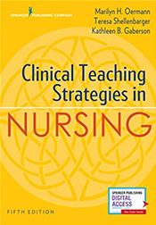
536 | The New Nurse Educator: Mastering Academe | Hunt | 2018  2nd ed | 9780826181824  Springer | $65.00 | Required
536 | The Legal, Professional, and Ethical Dimensions of Higher Education in Nursing | Smith | 2012  2nd ed | 9780826199539  Springer | $65.00 | Required

Course | Title | Author | Copyright | ISBN/Publisher | Price | Status
536 | The Scope of Practice for Academic Nurse Educators and Academic Clinical Nurse Educators | National League for Nursing | 2020  3rd ed | 9781975151928  NLN  NEW EDITION! | $19.95 | Required
545 Advanced Health Assessment & Diagnostic Reasoning for the Neonate  Enrollment: 10 | Imaging of the Newborn | Kirpalani, Epelman & Mernagh | 2011  2nd ed | 9780521896269  Cambridge University Press | $171.00 | Required
545 | Fanaroff & Martin’s Neonatal-Perinatal Medicine: Diseases of the Fetus & Infant, 2-volume set | Martin, Fanaroff & Walsh | 2020  11th ed | 9780323567114  Elsevier  NEW EDITION! | $279.99 | Required
545 | Physical Assessment of the Newborn: A Comprehensive Approach to the Art of Physical Examination | Tappero & Honeyfield | 2019  6th ed | 9780826174437  Springer  NEW EDITION! | $70.00 | Required | 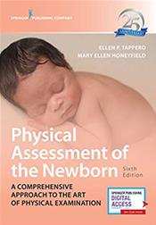
545 | Mosby’s Pocket Guide to Fetal Monitoring | Miller, Miller & Tucker | 2017  8th ed | 9780323401579  Elsevier | $48.95 | Required

Course | Title | Author | Copyright | ISBN/Publisher | Price | Status
549 Neonatal Management I  Enrollment: 10 | Neonatology: Management, Procedures, On Call Problems, Diseases, & Drugs | Gomella | 2020  8th ed | 9781259644818  McGraw-Hill  NEW EDITION! | $70.00 | Required | 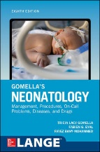
549/550 | Assisted Ventilation of the Neonate | Goldsmith | 2017  6th ed | 9780323390064  Elsevier Health Science | $99.99 | Required
549/550 | Fanaroff & Martin’s Neonatal-Perinatal Medicine: Diseases of the Fetus & Infant, 2-volume set | Martin, Fanaroff & Walsh | 2020  11th ed | 9780323567114  Elsevier  NEW EDITION! | $279.99 | Required
550 Neonatal Management II  Enrollment: 10 | MacDonald’s Atlas of Procedures in Neonatology | Ramasethu | 2019  6th ed | 9781496394255  Wolters Kluwer  NEW EDITION! | $139.99 | Required
554 Human Resource Management  Enrollment: 25 | Human Resource Management in Health Care: Principles and Practice | Fallon & McConnell | 2021  3rd ed | 9781284155136  Jones & Bartlett  NEW EDITION! | $85.95 | Required

Course | Title | Author | Copyright | ISBN/Publisher | Price | Status
560/561 Family Healthcare Management I & Advance FNP Practicum I  Enrollment: 40 | Nurse Practitioner’s Business Practice & Legal Guide | Buppert | 2018  6th ed | 9781284117165  Jones & Bartlett | $125.95 | Elective
560/561 | Clinical Guidelines in Primary Care | Hollier | 2018  3rd ed | 9781892418258  APEA  NEW BOOK FOR COURSE! | $109.95 | Required | 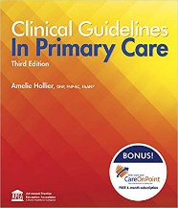
560/561 | Burns’ Pediatric Primary Care | Garzon Maaks et al. | 2021  7th ed | 9780323581967  Elsevier  NEW EDITION! | 141.00 | Required
560/561 | Family Practice Guidelines | Cash & Glass | 2017  4th ed | 9780826177117 or  9780826153418 (includes free app)  Springer | $110.00 | Elective
560/561 | Primary Care: Art & Science of Advanced Practice Nursing | Dunphy et al. | 2019  5th ed | 9780803667181  F. A. Davis  NEW EDITION! | $175.00 | Required

Course | Title | Author |  | Copyright | ISBN/Publisher | Price | Status
560/561 | Women’s Health Care in Advanced Practice Nursing | Alexander,  Johnson-Mallard,  Kostas-Polsten, Fogel &  Woods |  | 2017  2nd ed | 9780826190017  Springer | $115.00 | Required
560/561 | A Manual of Laboratory and Diagnostic Tests | Fischbach & Fischbach |  | 2018  10th ed | 9781496377128  Wolters Kluwer | $66.99 | Elective
560/561 | Essential Procedures for Practitioners in Emergent, Urgent, & Primary Care Settings: A Clinical Companion | Campo & Lafferty |  | 2016  2nd ed | 9780826171764  Springer | $80.00 | Elective | 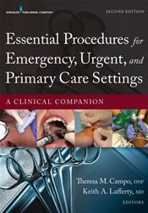
560/561 | 2021 Ferri’s Clinical Advisor: 5 Books in 1 |  | Ferri | 2020 | 9780323713337  Elsevier  Will publish in June | $99.99 | Elective
560/561 | DxR Clinician |  | DxR Development Group | 2020 | DxR Development Group | $75.00 | Required | Additional info will be provided in the course syllabus. The software will be available to purchase week 1.

Course | Title | Author | Copyright | ISBN/Publisher | Price | Status
Required for all FPMHNP courses | Diagnostic & Statistical Manual of Mental Disorders  (DSM-5) | American Psychiatric Association | 2013  5th ed | 9780890425558  American Psychiatric Publishing | $160.00 | Required for all FPMHNP courses
Required for all FPMHNP courses | Psychiatric-Mental Health Nursing: Scope & Standards of Practice | American Nurses Association | 2014  2nd ed | 9781558105553  American Nurses Association | $32.95 | Required for all FPMHNP courses | 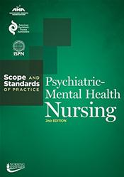
Required for all FPMHNP courses | The Prescriber’s Guide: Stahl’s Essential Psycho-pharmacology | Stahl | 2017  6th ed | 9781316618134  Cambridge University Press | $99.99 | Required for all FPMHNP courses
566 Family Mental Health Psycho-Pharmacology  Enrollment: 25 | Stahl’s Essential Psycho-  pharmacology: Neuroscientific Basis & Practical Application | Stahl | 2013  4th ed | 9781107686465  Cambridge University Press | $124.99 | Required
566 | The Prescriber’s Guide: Stahl’s Essential Psychopharma-  cology | Stahl | 2017  6th ed | 9781316618134  Cambridge University Press | $99.99 | Required

Course | Title | Author | Copyright | ISBN/Publisher | Price | Status
568 Advanced Assessment & Therapeutic Interventions  Enrollment: 12 | Psychiatric Advanced Practice Nursing: A Biopsychosocial Foundation for Practice | Perese | 2012  1st ed | 9780803622470  F A Davis | $156.00 | Required
568 | Kaplan & Sadock’s Synopsis of Psychiatry: Behavioral/  Clinical Psychiatry | Sadock et al. | 2015  11th ed | 9781609139711  Wolters Kluwer | $123.99 | Required
569 | The Psychiatric Interview | Carlat | 2017  4th ed | 9781496327710  Wolters Kluwer | $66.99 | Required
572 Advanced Psychiatric Nursing-Diagnosis & Management of Adults & Specialty Populations  Enrollment: 10 | Motivational Interviewing in the Treatment of Psychological Problems | Arkowitz et al. | 2017  2nd ed | 9781462530120  Guilford Press | $32.00 | Required
572 | Desk Reference to the Diagnostic Criteria from DSM-5 | American Psychiatric Association | 2013  5th ed | 9780890425565  American Psychiatric Press | $74.00 | Required | 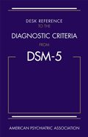

Course | Title | Author | Copyright | ISBN/Publisher | Price | Status
572 | Stahl’s Essential Psycho-  pharmacology: Neuroscientific Basis & Practical Application | Stahl | 2013  4th ed | 9781107686465  Cambridge University Press | $124.99 | Required
572 | The Prescriber’s Guide: Stahl’s Essential Psychopharma-  cology | Stahl | 2017  6th ed | 9781316618134  Cambridge University Press | $99.99 | Required
572 | The Psychiatric Interview | Carlat | 2017  4th ed | 9781496327710  Wolters Kluwer | $66.99 | Required
572 | Kaplan & Sadock’s Synopsis of Psychiatry: Behavioral/  Clinical Psychiatry | Sadock et al. | 2015  11th ed | 9781609139711  Wolters Kluwer | $123.99 | Required
572 | Theory and Practice of Group Psychotherapy | Yalom | 2005  5th ed | 9780465092845  Station Hill Press | $70.00 | Required
572 | Practice Guidelines for the Treatment of Psychiatric Disorders | American Psychiatric Association | 2006  1st ed | 9780890423851  American Psychiatric Press | $154.00 | Required

Course | Title | Author | Copyright | ISBN/Publisher | Price | Status
572 | Cognitive Behavior Therapy: Basics and Beyond | Beck | 2011  2nd ed | 9781609185046  Guilford Press | $57.00 | Required
640 Final FNP Practicum  Enrollment: 15 | Family Nurse Practitioner Certification Intensive Review: Fast Facts & Practice Questions | Codina Leik | 2017  3rd ed | 9780826134295  Springer  App included with print purchase | $80.00 | Required | 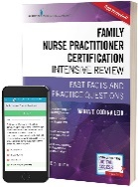
640 | DxR Clinician | DxR Development Group | 2020 | DxR Development Group | $75.00 | Required | Additional info will be provided in the course syllabus. The software will be available to purchase week 1.
707 Principles of Epidemiology & Health Promotion in APN  Enrollment: 25 | Caring for the Vulnerable: Perspectives in Nursing Theory, Practice, & Research | de Chesnay & Anderson | 2020  5th ed | 9781284146813  Jones & Bartlett  NEW EDITION! | $90.95 | Required
707 | Health Promotion in Nursing Practice | Murdaugh, Parsons & Pender | 2019  8th | 9780134754086  Pearson  NEW EDITION! | $99.00 | Required | 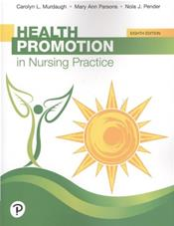
707 | Essentials of Epidemiology in Public Health  Bailey | Aschengrau & Seage | 2020  4th ed | 9781284128352  Jones & Bartlett | $89.95 | Required
Course | Title | Author | Copyright | ISBN/Publisher | Price | Status
710 Biostatistics  Enrollment: 25 | Munro's Statistical Methods for Health Care Research | Plichta Kellar & Kelvin | 2013  6th ed | 9781451187946  Wolters Kluwer | $85.99 | Elective | 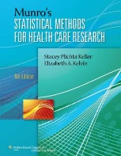
735 Interprofessional Collaboration & Advanced Program Planning  Enrollment: 25 | The Interprofessional Health Care Team: Leadership & Development | Weiss, Tilin & Morgan | 2018  2nd ed | 9781284112009  Jones & Bartlett | $79.95 | Required
736 Translation of Evidence-Based into Practice  Enrollment: 25 | Evidence-based Practice: An Integrative Approach to Research, Administration, & Practice | Hall & Roussel | 2017  2nd ed | 9781284098754  Jones & Bartlett | $104.95 | Required
736 | Project Planning & Management: A Guide for Nurses & Interprofessional Teams | Harris, Roussel, Dearman, & Thomas | 2020  3rd ed | 9781284147056  Jones & Bartlett | $83.95 | Required
736 | Evidence-Based Practice in Nursing & Healthcare: A Guide to Best Practice | Melnyk & Fineout-Overholt | 2019  4th ed | 9781496384539  Wolters Kluwer | $94.99 | Required

Course | Title | Author | Copyright | ISBN/Publisher | Price | Status
736 | Translation of Evidence into Practice: Application to Nursing & Health Care | White, Dudley-Brown, & Terhaar | 2019  3rd ed | 9780826147363  Springer  NEW EDITION! | $85.00 | Required
736 | Evidence-Based Nursing: The Research-Practice Connection | Brown | 2018  4th ed | 9781284099430  Jones & Bartlett | $109.95 | Elective | 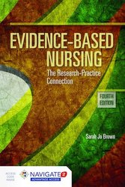
740 Impact of Ethics & Law on the Role of the DNP  Enrollment: 25 | Ethical and Religious Directives for Catholic Health Care Service | U.S. Conference of Catholic Bishops | 2018  6th ed | http://www.usccb.org/about/doctrine/ethical-and-religious-directives/upload/ethical-religious-directives-catholic-health-service-sixth-edition-2016-06.pdf  U.S. Conference of Catholic Bishops |  | Required
740 | Code of Ethics for Nurses with Interpretive Statements | American Nurses Association | 2015  2nd ed | 9781558105997  American Nurses Association | $33.95 | Required | 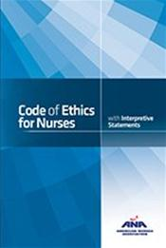
740 | Nursing Ethics & Professional Responsibility in Advanced Practice | Grace | 2018  3rd ed | 9781284107333  Jones & Bartlett | $87.95 | Required | 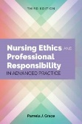
740 | Legal & Ethical Issues for Health Professions | Nguyen | 2019  4th ed | 9780323496414  Elsevier | $79.95 | Required
Course | Title | Author | Copyright | ISBN/Publisher | Price | Status
759 Information & Technology for Transformation of Healthcare  Enrollment: 25 | Nursing Informatics for the Advanced Practice Nurse | McBride & Tietze | 2019  2nd ed | 9780826140456  Springer Publishing | $115.00 | Required | 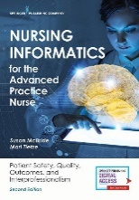
826.2 DNP-C Project II  828.2 DNP-L Project II  Enrollment: 10 | Nursing Practice Project: A Framework for Success | Moran, Buran & Conrad | 2020  3rd ed | 9781284156959  Jones & Bartlett | $92.95 | Required

