The College of Nursing has no bookstore. Textbooks can be purchased at the Peoria Barnes and Noble store (request them at the checkout counter), or purchased or rented online. Titles, prices, and quantity in stock are subject to change. If substantive changes are made to this list after publication, your instructor will contact you.
If you have questions, please call the College Library at 309-655-2180.
Prices posted are provided by the publishers and represent the price they charge to the public.

Course | Title | Author | Copyright | ISBN/Publisher | Price | Status
Required for all graduate courses | Publication Manual of the American Psychological Association | APA | 2020  7th ed | 9781433832154  APA  NEW EDITION! | $31.99 | Required for all graduate courses
Required for all graduate courses | Ethical and Religious Directives for Catholic Health Care Service | U.S. Conference of Catholic Bishops | 2018  6th ed | 9781601375988 (8.5” x 11” print booklet)  U.S. Conference of Catholic Bishops | $4.95 | Required for all graduate courses
Required for all graduate courses | Policy & Politics in Nursing & Health Care | Mason, Perez, McLemore, & Dickson | 2021  8th ed | 9780323554985  Saunders Elsevier | $113.00 | Required for all graduate courses | 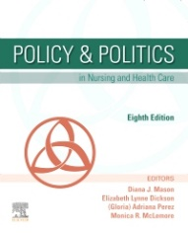
512 Roles and Issues in Advanced Practice Nursing  Enrollment: 50 | Hamric & Hanson’s Advanced Practice Nursing: An Integrative Approach | Tracy & O’Grady | 2019  6th ed | 9780323447751  Elsevier | $87.95 | Required | 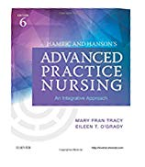

Course | Title | Author | Copyright | ISBN/Publisher | Price | Status
750 Cultural Competency  Enrollment: 25 | Cultural Competencies for Nurses: Impact on Health & Illness  (includes companion website access) | Dayer-Berenson | 2014  2nd ed | 9781449688073  Jones & Bartlett | $95.95 | Required
815 Organizational Management & Leadership in Healthcare Systems  Enrollment: 25 | Transformational Leadership in Nursing | Broome & Marshall | 2020  3rd ed | 9780826135049  Springer | $95.00 | Required | 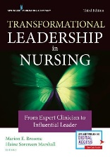
815 | Leadership: Theory and Practice | Northouse | 2019  8th ed | 9781506362311  Sage Publications | $88.00 | Required | 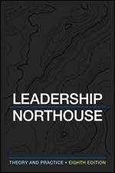
815 | Quantum Leadership: Building Better Partnerships for Sustainable Health | Porter-O’Grady & Malloch | 2018  5th ed | 9781284110777  Jones & Bartlett | $126.95 | Required | 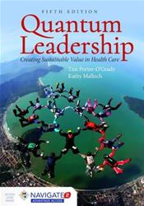
826.1  DNP- Clinical Project I | The Doctor of Nursing Practice Project: A Framework for Success | Moran, Burson & Conrad | 2020  3rd ed | 9781284156959  Jones & Bartlett | $100.95 | Required | 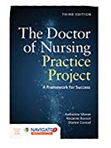
828.1  DNP- Leadership Project I | The Doctor of Nursing Practice Project: A Framework for Success | Moran, Burson & Conrad | 2020  3rd ed | 9781284156959  Jones & Bartlett | $100.95 | Required

