Region 2 SitRep (Situation Report)
October 2016

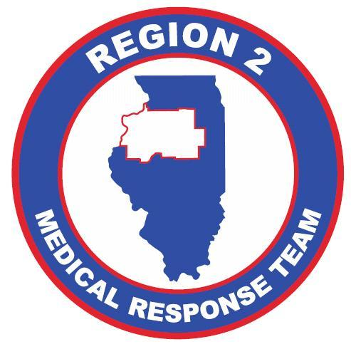

Stadard operating Procedure

-This plan was developed to establish procedures for the use of the Region 2 SitRep (Situation Report)

Region 2 – SitRep (Situation Report)
- Purpose
This standard operating procedure (SOP) addresses healthcare facilities in the Region 2 Healthcare Coalition in the use of the Online SitRep.
- Background
The Region 2 Healthcare Coalition is a group comprised of Regional Hospitals, Public Health Officials, Emergency Managers of City and Counties, and other healthcare entities within IDPH EMS Region 2. The region is comprised of 18 counties and 25 hospitals serving over 1 million persons in population. The Region 2 Healthcare Coalition also maintains Regional Response Assets housed within Regional Hospitals.
- SCOPE
This SOP lays out the procedures for the use of the online SitRep in support of:
  - A catastrophic incident or any event/incident involving multiple jurisdictions—especially incidents or events in which regional resource requests are anticipated and/or the activation of a Mutual Aid Agreement (MAA) is likely.
  - Situational awareness and planning support for a regional response to ensure that all actions are accomplished within the procedures and priorities established
- Assumptions
  - Assumptions
    - The Hospital or Agency is in Region 2
    - The individual completing this form is the liaison for their facility with the RHCC.
    - This form is not to make Emergency Notification to the RHCC. Emergency Notification must be made by phone to the RHCC or delegates.

Cont’d
- Using the sitrep form
  - When to use the form:
    - When a hospital or agency opens their Command Center or activates their Emergency Response Operations
    - During a Mass Casualty Incident or any event involving a Mass Influx of patients
    - When the ChemPak is deployed or requested.
    - During an incident that may require the use of MAA (Mutual Aid Agreements)
    - During an incident that may require the request for regional resources. (Any requests for resources should be made using a RFR –Request for Medical Resources)
    - During any Events of Significance such as large fires, significant weather events, or any emergent incident or event that may cause a significant change in daily operations for the facility.
  - How to use the form:
    - When describing the event or incident please use the following guidance:
      - Who – Who is this event impacting, including agencies outside of the reporting hospital.
      - What – What has happened? Please give a brief description of the event or incident.
      - Action – What actions have you taken or what actions will you be taking to respond to this event or incident.
      - Any Requests – Have you made any requests to the RHCC, City/County EOC, or any other agency involved. (Remember when making requests to the RHCC, please complete the RFR – Request for Medical Resources found on the Website).
  - How to access the form:
    - Browse to the OSF Disaster Preparedness Website (www.OSFSaintFrancis.org/Disaster)
    - Click on the SitRep
In the event of an IT failure or the Hospital or Agency Cannot Access the internet. A hard copy of the SitRep is found at the bottom of this document.
- Complete the Hard Copy SitRep form and fax it to the RHCC at (309)-683-8361
- Make contact with the RHCC or delegates to inform them an updated Sitrep has been sent.
Cont’d
- Areas of Responsibilities
  - Facility or Agency
    - Complete the online SitRep or Hard Copy SitRep
      - If completing the Hard Copy you must make contact with the RHCC or delegates to inform them an updated SitRep has been sent.
    - The SitRep must be completed within 30 minutes of the beginning or recognition of the incident. The goal is 15 minutes from the beginning of the incident or recognition of the incident.
      - If the incident duration exceeds 1 (one) Operational Period then a SitRep must be completed at the end of each Operational Period.
      - The SitRep should also be completed every time the Incident Objectives change.
  - RHCC
    - Once the RHCC has received the SitRep, the information will be compiled and disseminated to the region within 30 minutes of reception.

SitRep Hard Copy to follow below:

Region 2 – SitRep (Situation Report)

This form is to be used to update the Illinois Region 2 RHCC or the Region 2 Medical Response Team on an emergent situation in Illinois Region 2. This form is brief in format and should be as specific as possible. If this is a new Emergency then please contact the Region 2 RHCC as soon as possible. The intent of this form is to send updates, not to report an Emergency. If you have a request for resources. Please complete the "Request for Medical Resources" form on our website.
* - Required

Reporting Facility - *
The facility (Hospital/Medical Center) that is filling out this report.
.

Representative completing this report - *
Name of the representative from the facility that is completing this form.
.

Representative Contact Information - *
Contact information including name, e-mail, phone number (direct number, cell phone or extension)
.

Alternate Representative Contact Information
Contact information for an alternate representative in the event the primary is unavailable. Include, name, e-mail, phone number (direct number or extension)
.

Cont’d
Description of current situation - *
Please describe the situation as best as possible. (Who, What, Action, Any Requests)
.

Needs that have not been filled - *
Please describe any needs that have not or cannot be filled by your local resources (Fire, Police, EMS, EMA, ESDA, etc)
.

Any Other Information –
.
Do you need a representative to contact you? -*
Although this form is not intended to be a basis of contact in the event of an emergency. If you have information you feel is "Not for Disclosure" please let us know and we can contact you.
□ Yes
□ No

Please Fax this completed form to the RHCC at (309) 683-8361

