READ THIS FIRST!
The College of Nursing has no bookstore. Textbooks can be purchased at the Peoria Barnes and Noble store (request them at the checkout counter), or purchased or rented online. Titles, prices, and quantity in stock are subject to change. Prices posted are provided by the publishers and represent the price they charge to the public. If substantive changes are made to this list after publication, your instructor will contact you. If you have questions, please call the College Library at 309-655-2180.

Course | Title | Author | Copyright | ISBN/Publisher | Price | Status
304 Nursing & Healthcare Ethics  Enrollment: 115 | Nursing Ethics: Across the Curriculum and Into Practice | Butts & Rich | 2020  5th ed | 9781284170221  Jones & Bartlett | $99.95 | Required
304 | Ethical and Religious Directives for Catholic Health Care Service | U.S. Conference of Catholic Bishops | 2018  6th ed | http://www.usccb.org/about/doctrine/ethical-and-religious-directives/upload/ethical-religious-directives-catholic-health-service-sixth-edition-2016-06.pdf  U.S. Conference of Catholic Bishops |  | Required | 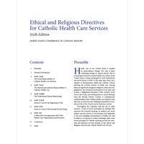
304 | Code of Ethics for Nurses with Interpretive Statements | American Nurses Association | 2015 | 9781558105997  American Nurses Association | $33.95 | Required | 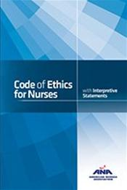

Course | Title | Author | Copyright | ISBN/Publisher | Price |  | Status
310 Health Assessment  Enrollment: 115 | Health Assessment in Nursing | Weber & Kelley | 2018  6th ed | 9781496344380  Wolters Kluwer |  | $124.99 | Required | 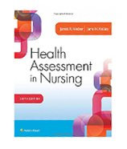
317 Concepts for Professional Nursing—RN  Enrollment: 25 | Advancing Your Career: Concepts in Professional Nursing | Kearney-Nunnery | 2020  7th ed | 9780803690141  F. A. Davis  NEW EDITION! |  | $79.95 | Required
318 Research for Nursing Practice  Enrollment: 115 | Essentials of Nursing Research: Appraising Evidence for Nursing Practice | Polit & Beck | 2018  9th ed | 9781496351296  Wolters Kluwer |  | $95.99 | Required | 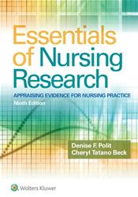
425 Promoting Healthy Communities  Enrollment: 25 | Community & Public Health Nursing: Evidence for Practice | DeMarco & Healey-Walsh | 2020  3rd ed | 9781975111694  Wolters Kluwer |  | $115.99 | Required | 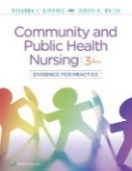
434 Concepts in Nursing Management  Enrollment: 115 | Leadership Roles and Management Functions in Nursing: Theory and Application | Marquis & Huston | 2021  10th ed | 9781975139216  Wolters Kluwer  NEW EDITION! |  | $89.99 | Required

Course | Title | Author | Copyright | ISBN/Publisher | Price |  | Status
436 Trends & Issues for Professional Nursing  Enrollment: 25 | Contemporary Nursing: Issues, Trends, and Management | Cherry & Jacob | 2020  8th ed | 9780323554206  Elsevier |  | $80.95 | Required
450 Transition to Advanced Nursing Practice  Enrollment: 10 | Leddy & Pepper’s Professional Nursing | Hood | 2018  9th ed | 9781496351364  Wolters Kluwer |  | $84.99 | Required

