READ THIS FIRST!
The College of Nursing has no bookstore. Textbooks can be purchased at the Peoria Barnes and Noble store (request them at the checkout counter), or purchased or rented online. Titles, prices, and quantity in stock are subject to change. Prices posted are provided by the publishers and represent the price they charge to the public. If substantive changes are made to this list after publication, your instructor will contact you. If you have questions, please call the College Library at 309-655-2180.

Textbooks Included in Tuition
Some of your textbooks have been purchased by the College of Nursing. If the booklist states the book was purchased institutionally, DO NOT BUY AGAIN. You may choose to rent or purchase a physical copy, but you will receive the e-book and access code on the first day of class regardless. These fees are non-refundable.
Look at the textbook list to determine which additional books you need to buy separately.

Course | Title | Author | Copyright | ISBN/Publisher | Price | Status | Included in College Costs
310 Health Assessment | Health Assessment in Nursing | Weber & Kelley | 2018  6th ed | 9781496344380  Wolters Kluwer | $129.99 | Required | No | 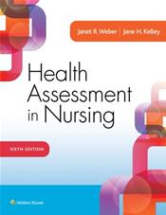
312 Pathophysiology | Gould’s Pathophysiology for the Health Professional | Hubert & VanMeter | 2018  6th ed | 9780323414425  Elsevier  NEW BOOK FOR COURSE! | Institutional | Required | Yes | 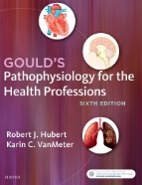
312 | Sherpath for Pathophysiology (online resource, includes textbook) | Hubert & VanMeter | 2017  6th ed | 9780323612463  Elsevier | Institutional | Required | Yes | 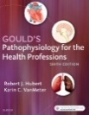
314 Pharmacological Basis for Nursing Practice | Pharmacology & the Nursing Process | Lilley et al. | 2019  9th ed | 9780323529495  Elsevier | Institutional | Required | Yes | 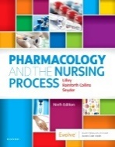
314 | Sherpath for Pharmacology & the Nursing Process (online resource, includes textbook) | Lilley et al. | 2020  9th ed | 9780323695282  Elsevier | Institutional | Required | Yes | 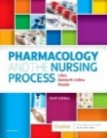

Course | Title | Author | Copyright | ISBN/Publisher | Price | Status | Included in College Costs
324 Conceptual Basis of Nursing I Theory | Concepts for Nursing Practice | Giddens | 2021  3rd ed | 9780323581936  Elsevier  NEW EDITION! | Institutional | Required | Yes | 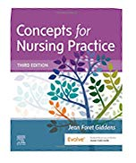
324 | Fundamentals of Nursing | Potter, Perry, Stockert & Hall | 2021  10th ed | 9780323677721  Elsevier  NEW EDITION! | Institutional | Required | No | 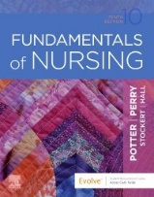
324 | Sherpath for Fundamentals of Nursing (online resource includes loose leaf textbook) | Potter et al. | 2016  9th ed | 9780323526715  Elsevier | Institutional | Required | Yes | 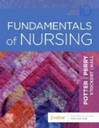
324 | Sparks & Taylor’s Nursing Diagnosis Reference Manual | Phelps, Sparks Ralph, & Taylor | 2021  11th ed | 9781975141745  Wolters Kluwer  NEW EDITION! | $71.99 | Required | No | 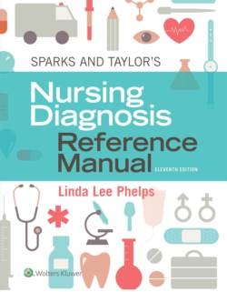
324 | A Manual of Laboratory and Diagnostic Tests | Fischbach & Fischbach | 2018  10th ed | 9781496377128  Wolters Kluwer | $66.99 | Required | No | 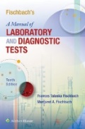
324 | Mosby’s Dictionary of Medicine, Nursing and Health Professions | Mosby | 2017  10th ed | 9780323222051  Elsevier | $44.95 | Elective | No | 