READ THIS FIRST!
The College of Nursing has no bookstore. Textbooks can be purchased at the Peoria Barnes and Noble store (request them at the checkout counter), or purchased or rented online. Titles, prices, and quantity in stock are subject to change. Prices posted are provided by the publishers and represent the price they charge to the public. If substantive changes are made to this list after publication, your instructor will contact you. If you have questions, please call the College Library at 309-655-2180.

Textbooks Included in Tuition
Some of your textbooks have been purchased by the College of Nursing. If it states the book was purchased institutionally, DO NOT BUY AGAIN. You will receive the textbook and access code on the first day of class. These fees are non-refundable.
Look at the textbook list to determine which additional books you need to buy separately.

Course | Title | Author | Copyright | ISBN/Publisher | Price | Status
304 Nursing & Healthcare Ethics  Enrollment: 115 | Nursing Ethics: Across the Curriculum and Into Practice | Butts & Rich | 2020  5th ed | 9781284170221  Jones & Bartlett  NEW EDITION! | $102.95 | Required
304 | Ethical and Religious Directives for Catholic Health Care Service | U.S. Conference of Catholic Bishops | 2018  6th ed | 9781601376022  (8.5” x 11” print booklet)  U.S. Conference of Catholic Bishops | $4.95 | Required | 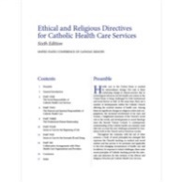
314 Pharmacological Basis for Nursing Practice  Enrollment: 25 | Pharmacology & the Nursing Process | Lilley et al. | 2020  9th ed | 9780323529495  Elsevier  NEW EDITION! | Institutional | Required | 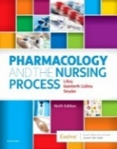
314 | Sherpath for Pharmacology & the Nursing Process (online resource) | Lilley et al. | 2020  9th ed | 9780323762106  Elsevier | Institutional | Required
318 Research for Nursing Practice  Enrollment: 50 | Essentials of Nursing Research: Appraising Evidence for Nursing Practice | Polit & Beck | 2018  9th ed | 9781496351296  Wolters Kluwer | $99.99 | Required | 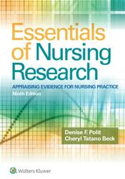

Course | Title | Author | Copyright | ISBN/Publisher | Price | Status
412 Trends & Issues for Professional Nursing  Enrollment: 75 | Nursing Today: Transition and Trends | Zerwekh | 2018  9th ed | 9780323401685  Elsevier | Institutional | Required | 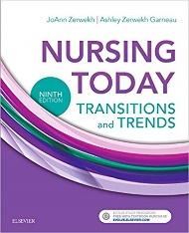
412 | Nursing Today: Transition and Trends (online resource) | Zerwekh | 2018  9th ed | 9780323553391  Elsevier | Institutional | Required

