|  |
| --- |
| Sign |

# Annual Pharmacology Update 2021

## Friday, November 5, 2021 - 7:30 AM to 4:45 PM

## Presented by Sigma Theta Tau Phi Omicron Chapter &

## Saint Anthony College of Nursing

*New Location this year!* 7 CEU’s applied for from ONA & AAPA

NIU Rockford Conference Center | 8500 E. State Street | Rockford, IL 61108

Topics include Heart Failure, Urology, Rheumatology, Diabetes, Arrhythmias, Dermatology, & Covid-19

Fees: SACN or SFMC Students, Faculty, or Alumni $40

Preceptors for Saint Anthony College of Nursing: ***Complimentary!***

All other participants $80

How to register: Visit SACN.edu, Email Jean.L.Odom@osfhealthcare.org, or call 815-282-7900

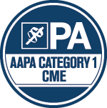

*OSF Healthcare is approved as a provider of nursing continuing professional development by the Ohio Nurses Association, an accredited approver by the American Nurses Credentialing Center's Commission on Accreditation. (OBN-001-91)*

LOGO Cent FNL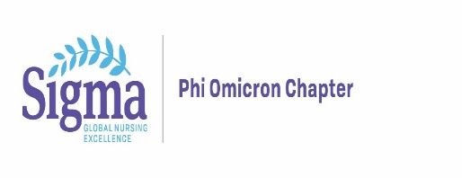

**Saint Anthony College of Nursing/ Sigma Theta Tau Phi Omicron**

**Annual Pharmacology Update**

**Friday, November 5, 2021**

**7:30 AM to 4:45 PM**

**NIU Conference Center, 8500 E. State Street, Rockford, IL 61108**

**Participant Registration Form**

Participant Name with credentials (required)



Organizational Affiliation



Email (required)



Meal choice* Please choose one:

Turkey/Swiss

Beef/Cheddar

Special diet (vegetarian/vegan/gluten free-please specify)



**Please return form to:** [**Jean.L.Odom@osfhealthcare.org**](mailto:Jean.L.Odom@osfhealthcare.org)

**OR Mail to:**

Sigma Theta Tau Phi Omicron Chapter at Saint Anthony College of Nursing   
ATTN: Jean Odom

3301 North Mulford Road, Rockford, Illinois 61114

**Payment Options:**

**Check payments**: Please make check payable to Sigma Theta Tau Phi Omicron Chapter and mail to address above **OR**

**Paypal**: [STTI493@gmail.com](mailto:STTI493@gmail.com) (please include your name in the notes section)

**You will receive a confirmation email once payment and registration is received.**